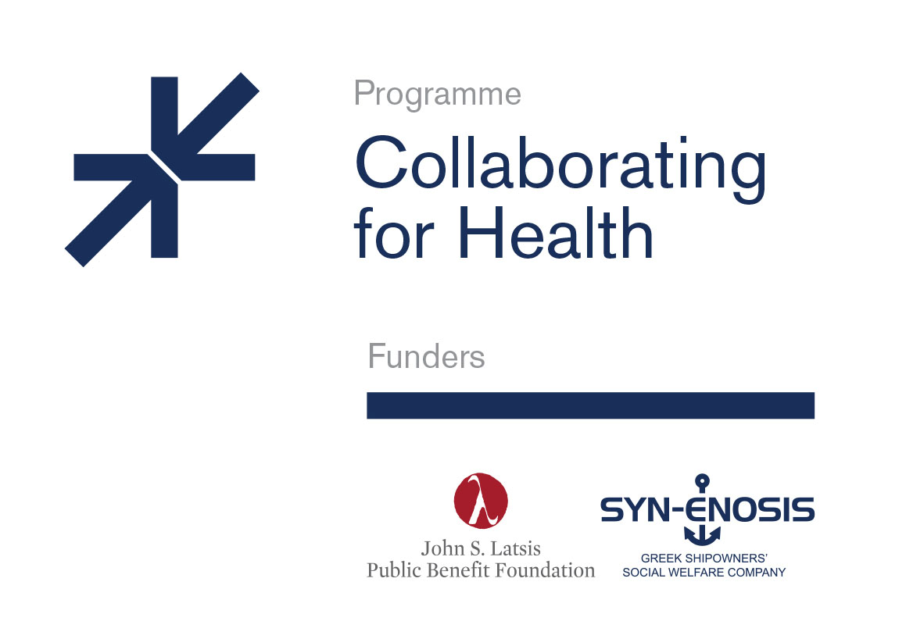

PRESS RELEASE
Wednesday February 6, 2019
The John S. Latsis Public Benefit Foundation and
the Greek Shipowners' Social Welfare Company SYN-ENOSIS Collaborate for Health

The John S. Latsis Public Benefit Foundation and the non-profit Greek Shipowners' Social Welfare Company SYN-ENOSIS today presented the results of the “Collaborating for Health” program, aimed at upgrading the infrastructure and supporting public health service providers in Greece. They also announced the program will continue through 2019.
This joint initiative was presented during the opening ceremony of the new angiographic imaging system (coronary angiographer) of the Interventional Haemodynamic Interventional Cardiology Department of "Sismanogleio - Amalia Fleming” General Hospital of Attica.
This donation, part of the first round of implementation of the "Collaborating for Health" initiative, is expected to cover 3,125 interventional operations per year (estimated rate of increase ~ 25%).
In 2018, the following donations were also initiated, co-funded by the two institutions:
- Donation of gastroenterological endoscopic instrumentation, for the upgrading of the Gastroenterological Department of "Evaggelismos" General Hospital,
- Donation of two patient beds with pressure sore prevention mattresses and electronic scale, and one machine of plasmapheresis and multiple treatment procedures, for the upgrading of the Coronary Care Unit of the Athens Navy Hospital,
- Donation of medical equipment, in collaboration with “Pediatric Trauma Care (Pedtrauma)” organization, to Filiates General Hospital – Health Center, for the improvement of the hospitalization of children, and equipment donation to the pediatric unit of Paxoi Health Center.
The John S. Latsis Public Benefit Foundation and the non-profit Greek Shipowners' Social Welfare Company SYN-ENOSIS announced the “Collaborating for Health” program will continue through 2019 and made a public call for the funding of small and medium scale projects. These projects cover the procurement of medical and technological equipment and/or the upgrading of current infrastructure, aimed at meeting essential requirements of the Public Health sector.
The public call is addressed to Public Health service providers (Hospitals and Health Centers) as well as to non-profit private legal entities active in the Public Health sector in Greece.
Through the Program, donations in kind will be implemented, co-financed by the John S. Latsis Public Benefit Foundation and the Greek Shipowners' Social Welfare Company SYN-ENOSIS, falling into the following categories: a) small-scale donations amounting to up to fifty thousand euros (€50,000) each, and b) medium-scale donations amounting to up to one hundred and fifty thousand euros (€150,000) each.
Mr. Athanasios Bousios, Executive Director of the Greek Shipowners' Social Welfare Company SYN-ENOSIS, said about the Program: "The continuation of this important joint initiative, launched in 2018 by the John S. Latsis Public Benefit Foundation and the Non Profit Greek Shipowners' Social Welfare Company SYN-ENOSIS, as well as the public call announced today highlight our commitment to actively contribute to the collective effort to upgrade health services in our country. The Greek shipping community has been standing by the country over the years; and through SYN-ENOSSIS, the Greek Shipowners' Union social welfare body, makes donations of broad public interest, focusing on key areas such as Health. Τoday's donation falls under this scope. "
Mr. Dimitris Afendoulis, Secretary to the Executive Board of the John S. Latsis Public Benefit Foundation, added: "Our experience in recent years has highlighted the particular importance and multiplier benefit of small and medium-scale donations in the public health sector. The "Collaborating For Health" Program focuses precisely on this funding gap and hopes to offer solutions in a coordinated way that will facilitate the patients', doctors' and nurses' everyday lives."
The full text of the public call for participation in the "Collaborating for Health" Program is available on the sponsors’ websites (www.latsis-foundation.org and www.syn-enosis.gr). The deadline for submitting applications expires on Friday, April 5, 2019, and the results will be announced on Friday, June 14, 2019, on the websites and social media of the Program sponsors.
For more information, interested parties may contact the John S. Latsis Public Benefit Foundation and SYN-ENOSIS, at the following e-mail addresses and phone numbers:
1. John S. Latsis Public Benefit Foundation: info@latsis-foundation.org, 210-6282888.
2. Greek Shipowners' Social Welfare Company SYN-ENOSIS: syn-enosis@syn-enosis.gr, 210-4291300-3.

